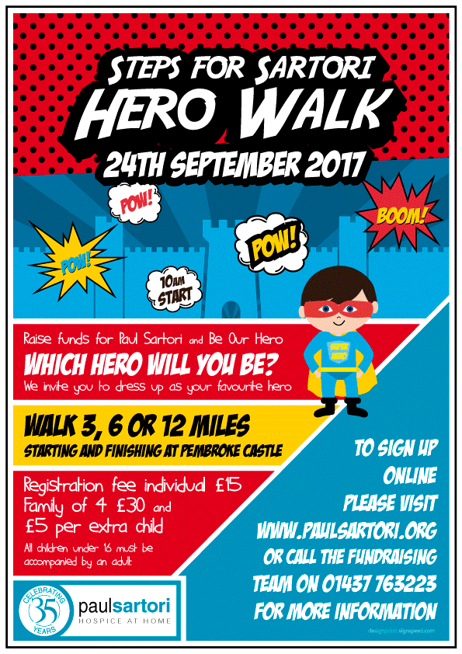
Steps for Sartori Hero Walk
Sunday 24th September 2017
Application Form

Full name ____________________________________

Address ____________________________________

____________________________________

____________________________________

Postcode ____________________________________

Telephone number _____________________________

Mobile number _____________________________

Email address _____________________________

Distance to be completed:
□ 12 mile □ 6 mile □ 3 mile
Please state names of your group:
Full name of participants  (inc. yourself) | Age of participant at time of walk | Male/female

Please note: Individual registration is £15, a family registration (2 adults, 2 children) is £30 and additional children are £5.

Please read statements and tick the boxes accordingly.
□ I wish to collect additional sponsorship. We will contact you to discuss this and can issue you with a sponsorship form
□ I understand that myself and/or my group will have to register on the day (registration from 8.00am until 9.30am) and that registrations fees paid will not be refunded if you are unable to attend.
□ I agree that the Paul Sartori Foundation can email me from time to time with information on Pembrokeshire’s Only Hospice at Home Service. Your details will not be passed onto third parties and we won’t bombard you with emails.

Payment method:
□ cash □ cheque □ card

Signed _____________________________ Full Name _____________________________

