 | 
  Application identification number (for office use only):

Confidential Employment Application Form
Please return the completed application form to:

or via e-mail to:

1. Vacancy Details
Position applied for
Closing date
Job Reference Number (If applicable)
Where did you see this position advertised?

2. Personal Details
Preferred title (e.g. Mr, M | rs, Miss, Mx, Dr, Prof.)
Forenames |  | Surname
Home Address
Home Telephone |  | Mobile Telephone
Email Address

Application identification number (for office use only):

Do you need a work permit to work in the UK? | Yes ☐ No ☐

Do you require reasonable adjustments to enable your access to an interview, should you be shortlisted? | Yes ☐ No ☐
If yes, what reasonable adjustments do you require?

BLANK PAGE

 | 
  Application identification number (for office use only):

Equal Opportunities Monitoring Form

Our charity recognises and actively promotes the benefits of a diverse workforce and is committed to treating all employees with dignity and respect.

In accordance with our equal opportunities policy, our charity will provide equality of opportunity to all employees and job applicants and will not discriminate either directly or indirectly on the grounds of race, sex, gender identity, marital status, disability, sexual orientation, religion/belief or age.

We have only asked for your name so that monitoring can take place at short listing and appointment stages. The monitoring form does not form part of your application and will therefore be detached from it on receipt, stored separately and will not be available to the selection panel. You can send it separately if you wish.

Personal Details: Please complete all sections

Age | 16-24 | 25-29 | 30-34 | 35-39 | 40-44
 | 45-49 | 50-54 | 55-59 | 60-64  Prefer not | 65+ to say

What best describes your Male Female ^{gender?} Prefer to self-describe | Prefer not to say  _________________________
Is your gender identity the same sex you were  Yes assigned at birth? | No | Prefer not to say
Are you Married or in a Civil Partnership? Yes | No | Prefer not to say

Sexual Orientation: Please tick against one of the following

Bisexual |  | Gay Man
Gay Woman / Lesbian |  | Heterosexual / Straight
Prefer to self-describe | ____________ | Prefer not to say

Religion or belief: Please tick against one of the following

No religion | Buddhist Christian
Hindu | Jewish Muslim
Sikh | Prefer not to say
Other | Please state: ___________________________________

Ethnic origin: Please tick against one of the following

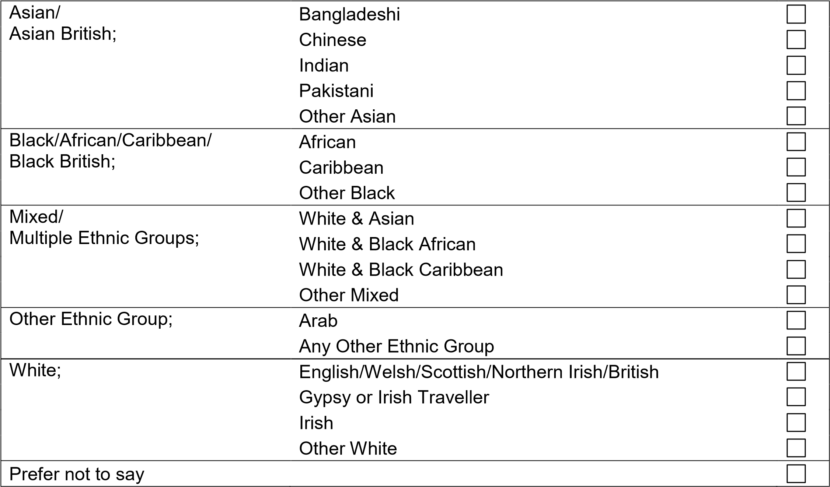

Disability: Please tick against one of the following

Do you consider yourself to have a disability?

You’re disabled under the Equality Act 2010 if you have a physical or mental impairment that has a
‘substantial’ and ‘long-term’ negative effect on your ability to do normal daily activities. Conditions covered may include, for example, severe depression, dyslexia, diabetes, epilepsy and arthritis.

Yes No Prefer not to say

PLEASE NOTE: This information is provided for monitoring purposes only – if you need reasonable adjustments you should arrange these separately.

Do you have caring responsibilities? If yes, please tick all that apply:
No caring responsibilities
Primary carer of a child/children (under 18)
Primary carer of disabled child/children
Primary carer of disabled adult (18 and over)
Primary carer of older person
Secondary carer (another person who assists the primary carer)
Prefer not to say

Thank you for completing this form and enabling us to monitor our Equality and Inclusion Policy.

BLANK PAGE

Application identification number (for office use only):

3. Qualifications, Training and Development
Please list the name of the qualifications, training and development courses you have attended; that are relevant to your application.
Title of qualification or course, including grades if applicable | Date Awarded/ Completed

4. Membership of Professional Bodies Please provide details:

5. Language Skills
I am able to: | Understand | Speak | Read | Write
Welsh | ☐ | ☐ | ☐ | ☐
English | ☐ | ☐ | ☐ | ☐
Other:  (Please Specify) | ☐ | ☐ | ☐ | ☐

6. General
Full Valid Driving Licence ☐ Use of car ☐

Any current endorsements? ☐Yes ☐No. Any motoring prosecutions pending? ☐Yes ☐No
If yes, please give details below If yes, please give details below

Details of any current endorsements or prosecutions pending?

Pre-employment checks

- Are you currently bound over or have you ever been convicted of any offence by Yes/No a Court or court-martial in the United Kingdom or in any other country? (you must include ‘spent ‘ convictions)

- Have you ever received a police caution, reprimand or final warning? Yes/No

- Have you been charged with any offence in the United Kingdom or in any other Yes/No country that has not yet been disposed of?

- Are you aware of any current police investigations in the United Kingdom or in Yes/No any other country following allegations made against you?

- Have you ever been dismissed by reason of misconduct or gross misconduct, Yes/No from any employment, office or any other position previously held by you?

- Have you ever been disqualified from the practice of a profession or required to Yes/No practice subject to specified limitations following fitness to practice proceedings by a regulatory or licensing body in the United Kingdom or in any other country?

- Are you currently the subject of any investigation, fitness to practice proceedings Yes/No by a regulatory or licensing body in the United Kingdom or in any other country?

- Are you subject to any other prohibitions, limitation or restriction that means the Yes/No Foundation is unable to consider you for the post for which you are applying?

If you are a registered nurse, please give your NMC number and expiry date:

If the answer to any of these questions is ‘YES’ please supply details on a separate sheet. Replying ‘YES’ will not necessarily bar you from employment

7. Current or Most recent Employment
Name of employer
Address of employer
Job title: |  | Date appointed to post
Brief description of duties
Reason for leaving |  | Period of notice required

8. Employment History
Please give a summary of all other employment (including previous posts held with your present or most recent employer) starting with the most recent first. If you are applying for a Clinical role please ensure you have accounted for any gaps in employment history. Please continue on a separate sheet (s) if necessary.

Dates  From - To | Name and location of employer | a) Job title, b) brief description of duties and;  c) reason for leaving

9. Employment Related References
Please provide details of two work related referees who will be able to describe your suitability for this post. The first of these should be your present or most recent employer. All offers of employment are subject to the company being satisfied with the work references received. If you are applying for a Clinical nursing role we would request that one of your references is a Registered Nurse if possible.
*Please refer to section 7 if you are unable to complete this section due to limited working experience.

 | 1st Referee
Name
Address
Tel |  | E-mail
Position held by referee |  | Employment relationship

 | 2nd Referee
Name
Address
Tel |  | E-mail
Position held by referee |  | Employment relationship

10. Character Reference
If you have not worked before, or if you have recently left full-time education, please provide details of someone who can offer a character reference about you.

 | Referee
Name
Address
Tel |  | E-mail
Relationship to applicant

11. Letter of Application
Please read the job description and person specification for the post. Using the information provided, please complete this section to let us know what skills, talents and abilities you think you can bring to the company and what qualities you have to do the job. Please note: CV’s will not be accepted.

Data protection statement
All of the information collected in this form is necessary and relevant to the performance of the job applied for. We will use the information provided by you on this form, to contact the referees you have noted, and the educational institutions with whom we may undertake to verify your qualifications, for recruitment purposes only. The Company will treat all personal information with the utmost confidentiality and in line with current data protection legislation. We rely on the lawful basis of Data Protection Act 2018 to process the information provided by you in this form.

Should you be successful in your application, the information provided, and further information which will be gathered at the relevant time, will be subsequently used for the administration of your employment and in relation to any legal challenge which may be made regarding our recruitment practices. The information you provide will be used for its intended purpose only and will be kept in your employee file.

Unsuccessful applicants’ details will be retained to create a potential reserve list of candidates for future vacancies, and to respond to any potential discrimination claims from unsuccessful candidates, all ‘unsuccessful’ application forms, CVs, and interview notes will be kept in a job-specific recruitment file for 6 months after the appointment has been filled.
Declaration
I confirm that the above information is complete and correct and that any untrue or misleading information will give my employer the right to terminate any employment offered. I understand that any offer of employment is subject to the Company being satisfied with the results of series of relevant checks including references, eligibility to work in the
UK, criminal convictions, probationary period and a medical report (in line with the operation of the Equality Act 2010).

Signed:

Date:

